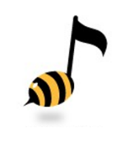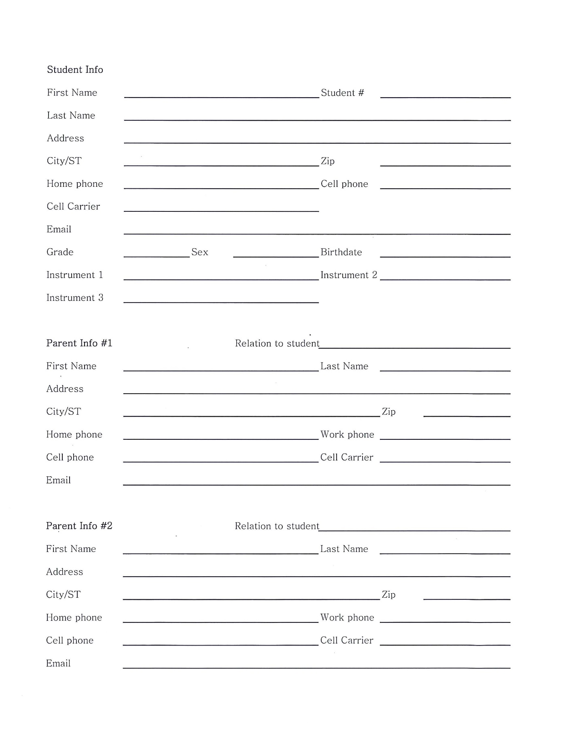

**Cut Time STUDENT INFO**

**SAHS BAND PROGRAM**

**2022 - 2023 SCHOOL YEAR**